SHIBA trainer notes for February 2022
Topic: Welcome to Winter! Medicare Part B Special Enrollment Period (SEP)

Table of Contents
Volunteer packet supplemental training materials
- Cover page with table of contents P. 1
- Review of purposes P. 2
- Statement of intent/context P. 4
- Course objectives for Part 1 SEP Program February P. 6
- Instructions for volunteers P. 7
- Scenario for Theresa - no highlights P. 8
- Worksheet for notes – blank P. 11
- Scenario for Theresa - with highlights P. 14
- Worksheet for notes – completed P. 16
- Beneficiary Contact Form (BCF) – blank P.23
- Beneficiary Contact Form (BCF) – completed P. 25
- Thank you! P. 27

Additional trainer packet materials
Trainer notes
- Tim’s guidance for working through the overall content P. 29
- Tim’s suggestions for dry run through the slides P. 29
- SEP, currently employed person P. 31
- Trainers’ notes review with volunteers P. 32
- Course objectives: trainer notes P. 33
- Counseling interview cycle P. 34
- PowerPoint slide deck first slide P. 35
- SHIP TA Center job aid: New to Medicare P. 36
- Medicare Rights Part B SEP P. 37
- Nine-block diagram for training objectives P. 38
- Nine-block example P. 39
- Thanks! P. 40
Review of purposes
Duplicated from the volunteer packet.

Notes to volunteers and volunteer coordinators

Across 2022 we’re going to use the monthly meetings and the CE programs we offer to:
- Get better at each of the three (3) kinds of programs we offer to volunteer and in-kind advisors
- Basic Training
- Mentoring
- Continuing education
- Collect feedback about the tools and resources we offer to volunteers and clients and the public:
- Job aids
- Publications
- Web sites
  - My SHIBA
  - OIC website
- Sharpen our focus on record-keeping in STARS
- Client-centered data, which is useful for building proficiency
- Demographic data, which is useful for program management
Our 60-minute continuing education (CE) program is focused on several learning objectives. This supports our efforts to make our training more “modular” and anticipates using brief video programs. At this time, offering a brief, focused CE program also helps us to manage our staff transitions and impacts on workloads.

(Reference note for RTCs: See the nine-block diagram.)

We appreciate your help to collect feedback that can help us provide the right tools and resources for each of our programs, for volunteers at all levels of proficiency.

We’re going to learn the habit of sharing data about performance more regularly with volunteers and volunteer coordinators (VCs). A great deal of these data will come from STARS.
We’re going to provide data for:
Duplicated from the volunteer packet.
- Each volunteer
- Each sponsor site or contractor
- The SHIBA program

We need these data in STARS to:
- Satisfy our funders Administration for Community Living (ACL) and Office of the Insurance Commissioner (OIC)
- Manage our contracts
- Support volunteer proficiency
- Assess the impacts of our work on the community
- Make better decisions about how we use our limited resources

(SHIBA office reference only: Note to vols and VC's.docx)

Statement of intent/context
Duplicated from the volunteer packet.

Special Enrollment Period (SEP) is one part of several enrollment periods: both getting started with Medicare and switching Medicare plans.

This is a two-part program about the SEP document. For today, we’re focusing on the “Getting Started” SEP for Medicare Parts A and B and not SEPs for Medicare Parts C and/or D.

Getting started

Initial Enrollment Period (IEP)

Special Enrollment Period (SEP)

General Enrollment Period (GEP)

II. Switching Coverage

Annual Changes

Medicare Open Enrollment Period (OEP)

Medicare Advantage (OEP)

MA and Part D specific changes (SEP)

Qualify for Extra Help

Service area move by beneficiary

5-star quality rating

Move to skilled nursing facility (SNF) or other institution

Plan non-renewal

MA, only

Join for the FIRST time

Part D, only

Auto-enroll

Pay for Part A, Part B GEP

(SHIBA office reference only: Organization for enrollment topics.pdf)

Continued

Statement of intent/context (continued)
Duplicated from the volunteer packet.

This is a two-part program about SEP.

In Part 1, we focus on a review of the facts.
- What do we need to know?
- This would lend itself to a kind of checklist or decision tree that would also be helpful to a mentor.
In Part 2, we focus on the skill of gathering the facts we need.
- How do we ask and listen to get the facts?
- This is more art than science.
- We want to ask: What are the tools and resources you need and your client would benefit from having to make the counseling most effective?
- This program includes the topic: How to screen for Extra Help. (What to do if a client appears eligible will be another program we’ll offer soon.)

(SHIBA office reference only: Intro to 2-part program on SEP.docx)

Course objectives for Part 1 SEP program - February
Duplicated from the volunteer packet.

Course objectives

I know Medicare-eligible beneficiaries may qualify for a special enrollment period (SEP) if they work past age 65.

There are specific criteria.

I know the effective date of Part B coverage depends upon several factors, including when and how clients complete their enrollment request.

I know I’m expected to gather certain data about the client—both for advising them about their rights and options, and for record-keeping.

Based on the facts a client shares with me, I know how to complete the STARS BCF record accurately and completely.

(SHIBA office reference only: Learning objectives for SEP Part 1 abbreviated.docx)

Instructions for volunteers
Duplicated from the volunteer packet.

Instructions for volunteers
Please carefully read over the scenario for Theresa.

Highlight the passages that are important and number these. For example, the passage that “Theresa is currently working” is important. So, highlight that.
NOTE: Most of these passages are important, so expect a long list.
Number each passage you highlighted – let’s number “Theresa is currently working” as number one.

Using the form provided on page 11 of this packet, please complete these columns:
- The text that seems important | - Passage number | - This matters for advising about options | - Why/how does this matter? | - This matters for record-keeping (this is important to record in STARS) | - Say (briefly) how you might get this kind of fact when you’re counseling
Example  Theresa is currently working. | The number you assigned. | Check if important to your counseling. | Say (briefly) why this matters to your counseling. | Check if yes. | We’ll cover this column in the next training.

(SHIBA office reference only: Instructions for volunteers.docx)

Scenario for Theresa - no highlights
Duplicated from the volunteer packet.

Theresa is currently working – proudly completing her 20th year -- for Target, the super department store. She really enjoys the work and the people she supervises, and the new technology. So, she continued to work until she qualified for her full social security benefit. She’s now 68 years old and ready to move on to her retirement passions.

She’s a U.S. citizen and has lived in Shelton (Mason County, WA) for her entire adult life. She moved back home after completing her bachelor’s degree at Washington State University in speech pathology. She’s going to stay there and has no plans to travel outside the U.S. in the near future. Her pet project at home is quilting, so she’s going to buy an expensive machine to help with large-scale projects.

Theresa is an active member of her local Catholic church and a dedicated volunteer at the St. Vincent DePaul thrift store the church sponsors. She also helps at the local food pantry, including collecting food from Target that they donate. She describes herself as very fortunate because she owns her own home, has put aside a nest egg of about $300,000 for retirement and will have a pension from Target as well as her Social Security income. She sees how “poor people in our town” struggle and she’s grateful for the blessings she has.

She never married or had children of her own, but she dearly enjoys the company of her younger sister who lives in Olympia and her three teen-age children (whom she dotes on constantly).

Theresa, in her own judgment, is relatively healthy and active. She had a knee replacement surgery a few years ago – at Providence St Peter Hospital in Olympia – and made a full recovery, including taking physical therapy as an outpatient through the Mason General Hospital, in Shelton. She’s on a maintenance level dose of a blood pressure medicine – she thinks it’s related to stress, but she does have some family history of stroke so she’s careful.

Continued
Duplicated from the volunteer packet.

Target employs many thousands of people in the US and offers generous health insurance coverage to employees and retirees, including full prescription drug coverage. Theresa plans to continue her retiree coverage, including prescription
coverage, with Target. There are several plan offerings, and her intention is to choose one that includes access to Providence Hospital and the health care professionals at Mason General Hospital (a not-for-profit hospital that is part of a local hospital district). She’s not attracted to leave her retiree plan – although she is impressed by the Joe Namath commercials on TV.

The two questions that are top of mind for her relate to getting started in Medicare – how and when does she take action? – and what might she have missed that we can tell her?

She’s calling us in mid-February. Her 69th birthday is May 1. She’d like to retire (stop working) by June 1 – she’d like to miss the start of planning for the Christmas season, but she’d like to work one more “Spring Break” sales event.

(SHIBA office reference only: Scenario for SEP.docx)

See next two pages for blank exercise worksheet.

Worksheet for notes – blank
Duplicated from the volunteer packet.
- The text that seems important | - Passage number | - This matters for advising about options | - Why/how does this matter? | - This matters for record-keeping (this is important to record in STARS) | - Say (briefly) how you might get this kind of fact when you’re counseling
Example  Theresa is currently working. | 1 | X | Because she might have health insurance coverage from her employer, now. | X | We’ll cover this column in the next training.

(SHIBA office reference only: Volunteer workbook, coaching job aid.xlsx Use first tab.)

Scenario for Theresa - with highlights
Duplicated from the volunteer packet.

SEP, currently employed person

Theresa is currently working – proudly completing her 20th year -- for Target, the super department store. She really enjoys the work and the people she supervises, and the new technology. So, she continued to work until she qualified for her full social security benefit. She’s now 68 years old, and ready to move on to her retirement passions.

She’s a U.S. citizen and has lived in Shelton (Mason County, WA) for her entire adult life. She moved back home after completing her bachelor’s degree at Washington State University in speech pathology. She’s going to stay there and has no plans to travel outside the US in the near future. Her pet project at home is quilting, so she’s going to buy an expensive machine to help with large-scale projects.

Theresa is an active member of her local Catholic church and a dedicated volunteer at the St. Vincent DePaul thrift store the church sponsors. She also helps at the local food pantry, including collecting food from Target that they donate. She describes herself as very fortunate because she owns her own home, has put aside a nest egg of about $300,000 for retirement and will have a pension from Target as well as her Social Security income. She sees how “poor people in our town” struggle and she’s grateful for the blessings she has.

She never married or had children of her own, but she dearly enjoys the company of her younger sister who lives in Olympia and her three teen-age children (whom she dotes on constantly).

Theresa, in her own judgment, is relatively healthy and active. She had a knee replacement surgery a few years ago – at Providence St Peter Hospital in Olympia – and made a full recovery, including taking physical therapy as an outpatient through the Mason General Hospital, in Shelton. She’s (only) on a maintenance level dose of a blood pressure medicine – she thinks it’s related to stress, but she does have some family history of stroke so she’s careful.
Duplicated from the volunteer packet.

Target employs many thousands of people in the U.S. and offers generous health insurance coverage to employees and retirees, including full prescription drug coverage. Theresa plans to continue her retiree coverage, including prescription coverage with Target. There are several plan offerings, and her intention is to choose one that includes access to Providence Hospital and the health care
professionals at Mason General Hospital (a not-for-profit hospital that is part of a local hospital district). She’s not attracted to leave her retiree plan – although she is impressed by the Joe Namath commercials on TV.

The two questions that are top of mind for her relate to getting started in Medicare – how and when does she take action? – and what might she have missed that we can tell her?

She’s calling us in mid-February. Her 69th birthday is May 1. She’d like to retire (means stop working) by May 30. Her employer-sponsored coverage will end then, too. She’d like to miss the start of planning for the Christmas season, but she’d like to work one more “Spring Break” sales event.

(SHIBA office reference only: Scenario for SEP highlighted.docx)

Worksheet for notes – completed
Duplicated from the volunteer packet.
- The text that seems important | - Passage number | - This matters for advising about options | - Why/how does this matter? | - This matters for record-keeping (this is important to record in STARS) | - Say (briefly) how you might get this kind of fact when you’re counseling
Example  Theresa is currently working. | 1 | X | Because she might have health insurance coverage from her employer, now. | X (Topics Discussed) | We’ll cover this column in the next training.
Proudly completing her 20th year. | 2 | X | Because she has enough work quarters to get Part A with no premium. | No | How long have you worked for an employer where you contributed to Social Security?
Target, the super department store. | 2 | X | If you know Target, you know it's a large employer (more than enough employees that Medicare will NOT be the primary insurance while she is working. | No
She continued to work until she qualified for her full social security benefit | 2 | X | You know she is not drawing benefits for Social Security already. | X (Topics Discussed)
She’s now 68 years old. | 3 | X | Because she’s eligible for Medicare by age (65 or older) - her eligibility is not related to disability. | X
She’s a U.S. citizen. | 4 | X | Because she’s eligible by citizenship. | No
Lived in Shelton (Mason County, WA) for her entire adult life. | 5 | X | Her zip code matters; where she lives affects her MA plan choice. | X
Has no plans to travel outside the U.S. | 5 | X | Things like foreign travel can influence people's preferences for (Original Medicare vs MA) insurance plans. | X (Topics Discussed)
A nest egg of about $300,000 for retirement and will have a pension from Target as well as her Social Security income. | 6 | X | Because by her income and assets (resources) she is not eligible for Extra Help. | X
She never married or had children of her own. | 7 | X | Because she is not a dependent (her own coverage matters) and she has no dependents (on her coverage) - so her choices do not affect others. | No
Relatively healthy and active. | 7 | X | Important to know people's own self-assessment because it affects their plan choices. | X (Topics Discussed)
Only on a maintenance level dose of a blood pressure medicine. | 7 | X | Important to know people's current or planned medication because it affects their plan choices. | X (Topics Discussed)
Target employs many thousands of people in the U.S. | 8 | X | Target, is a large employer (more than enough employees that Medicare will NOT be the primary insurance while she is working). | X (Topics Discussed)
Target offers generous health insurance coverage to employees and retirees. | 9 | X | Because she has access to retiree health insurance and may not need to buy more insurance from a private company. | X (Topics Discussed)
Target offers full prescription drug coverage. | 10 | X | Because she likely has creditable drug coverage - she can ask for a notice from the employer, if she needs it. | X (Topics Discussed)

(SHIBA office reference only: Volunteer workbook, coaching job aid.xlsx Use second tab)

See next two pages for the black Beneficiary Contact Form.

Beneficiary Contact Form (BCF) – blank
Duplicated from the volunteer packet.
Page 1 of 2

See My SHIBA for the links to the Beneficiary Contact Form.

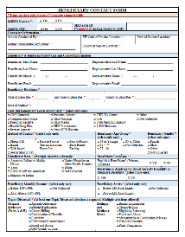

(SHIBA office reference only: Beneficiary_Contact_Form from SHIP TA Ctr.pdf)
(SHIBA office reference only: Insert full page version of page 1 of the Blank BCF into the final PDF)

Insert page number on PDF
Beneficiary Contact Form (BCF) – blank
Duplicated from the volunteer packet.
Page 2 of 2

See My SHIBA for the links to the Beneficiary Contact form.

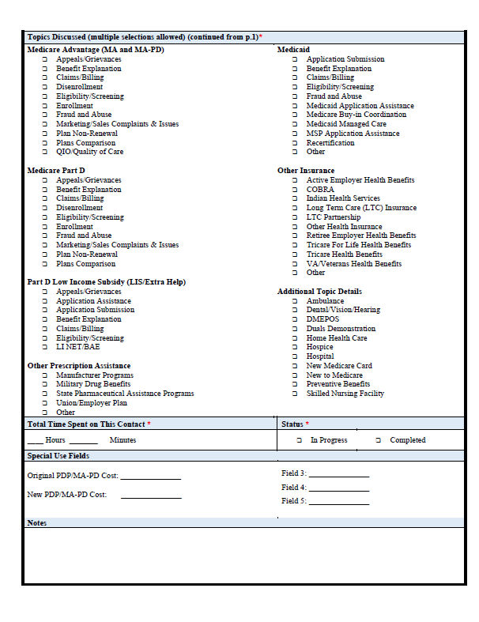
(SHIBA office reference only: Beneficiary_Contact_Form from SHIP TA Ctr.pdf)
(SHIBA office reference: Insert full page of page 2 of the Blank BCF into the final PDF in lieu of this page

Insert page number on PDF
Beneficiary Contact Form (BCF) – completed
Duplicated from the volunteer packet.
Page 1 of 2

See My SHIBA for the links to the completed Beneficiary Contact form.

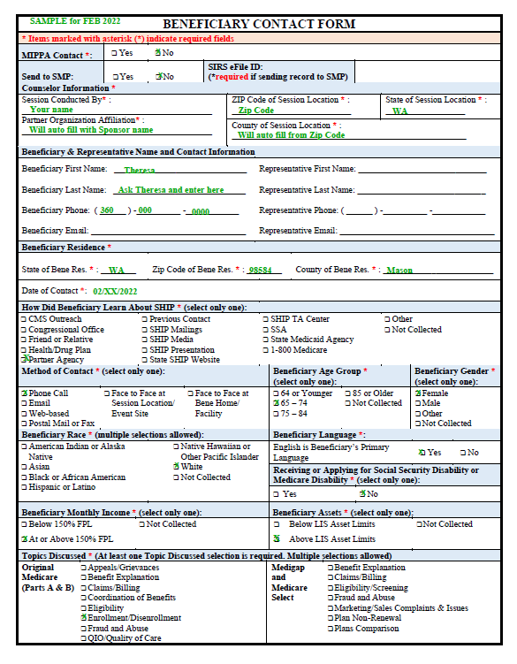

SHIBA office reference only: Beneficiary_Contact_Form Completed Form Liz 1-11-22.pdf)
(SHIBA office reference: Insert full page of page 1 of the completed BCF into the final PDF in lieu of this page)

Insert page number on PDF
Beneficiary Contact Form (BCF) – completed
Duplicated from the volunteer packet.
Page 2 of 2

See My SHIBA for the links to the completed Beneficiary Contact form.

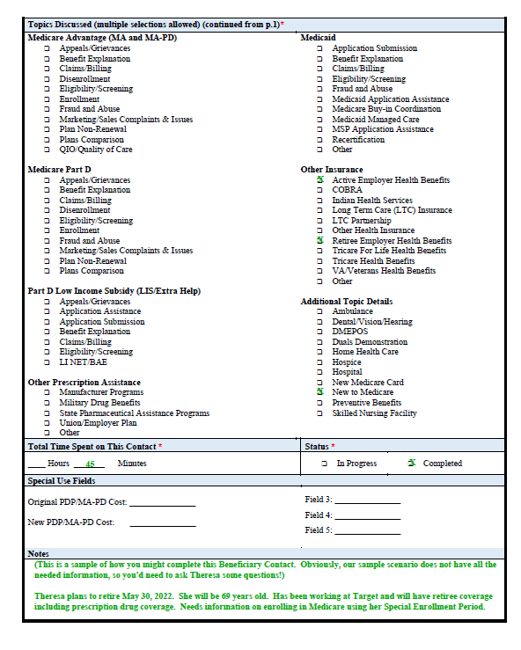

SHIBA office reference only: Beneficiary_Contact_Form Completed Form Liz 1-11-22.pdf)
(SHIBA Office reference: Insert full page of page 2 of the Completed BCF into the final PDF in lieu of this page)

Insert page number on PDF
Duplicated from the volunteer packet.

If you have questions, please be sure to contact your
Regional Training Consultant or Volunteer Coordinator.

Thanks, and have a great day of training!

Supplemental materials for the volunteer packet
are on the pages prior to this page.

Materials specific to SHIBA Regional Training Consultants
are on the pages following this page.
Trainer notes

Tim’s guidance for working through the overall content:
- Note to volunteers and VCs.
- Intro to 2-part program on SEP.
- Trainer notes.
- Organization for enrollment topics.
- Part 1 SEP packets.
- PowerPoint program since that is the “run of show” and has the timed agenda.
  - You can see where each handout for volunteers comes into play.
    - In general, there is a “blank” and “completed” version of each form.

Tim’s suggestions for dry run through the slides:
- Welcome.
- Walk through the agenda topics and then the slide with the timing with explanations.
- Walk through the course objectives.
- Review of first exercise. With a look at Scenario with Theresa scenario for SEP doc. Attendees read through this with the instructions for volunteers doc. And bring up the volunteer workbook, coaching job aid.xlsx and talk about how to walk through this.
- Now the volunteers have all the info and will work for 10 minutes. In the dry run, this is a test to see how this will work.
- Review of second exercise. See the trainer notes regarding you may or may not have finished.
- Now we’ll get together in small groups. Then the RTC can give instructions about how to go through this content.
- Now come back together. What are some things you would like to share about what happened in your group?
- Now let’s look at the BCF because it’s important to know how to fill out the forms. In the packet there is a blank BCF. In your packet, there also is a form you can use to help fill out the information from the exercise. What is being reinforced is that it’s important to know how to fill out the BCF.
- Then take time to debrief about how this relates back to the instruction. What the trainer should show is a version of the scenario with Theresa scenario for SEP highlighted doc to review with the group. There is room here for different ideas knowing that we may not all see this the same way. So, the trainer can look at one version of the scenario that looks at why the BCF is important for various reasons. The volunteers should see versions of the documents that are blank and also filled out for reference and review.
- Then go back and look at the learning objectives for the course. Do you now feel more confident based on the learning objectives outlined? Presuming that volunteers do, then talk about what comes next in terms of next month’s topics and resources and evaluations.

SEP, currently employed person

Start-up
Welcome
Introductions
Review the agenda
Exercises
Exercise #1
- Review the case study and complete the worksheet.
Exercise #2
- Ask volunteers to meet in groups of 2-3 to discuss their own worksheets and ideas.
  - For example, what did you write into the section for how you might ask?
Exercise #3
- Ask each small group to share some observations with the whole group.
- Sample Q’s
  - What did your team talk about?
  - What was unexpected?
  - What did we miss in the worksheet?
Exercise #5
- Complete the BCF.
Exercise #6
- De-brief.

(SHIBA office reference only: Draft 60-minute program for SEP.docx)
Trainers’ notes review with volunteers
SEP, currently employed person

Script for intro

For this program to work as a focused learning experience, in the context of a 60-minute CE program with many people participating, we need to provide some context for the case study. The key here is for a person to have a chance to practice the skill of counseling and to exchange ideas and observations about counseling with each other and the RTC. It’s also important we take some time to practice with the Beneficiary Contact Form (BCF), which is about data entry in STARS.

Part of how we’re going to provide this focus is to describe certain (simplifying) instructions about the case and the person involved in the case. Of course, in real-life counseling a great deal of the important work of the volunteer advisor is to ask questions of the client (or their representative) that lead to these important details about the person and their circumstances. In providing these facts, we anticipate that you could discuss the reasons why knowing these facts matter and even how you might go about asking the questions that lead to gathering and recording these facts.

There is a checklist in the packet that describes some of these important facts. Please let us know what else you might consider to be important and why.

Next time
– and how you’d ask to discover this.
One thing that can support the conversation between the volunteer advisor and the client is the use of resources to which the advisor (and the client) has access. This can be things like job aids, publications, webpages, Medicare & You handbook, etc. As part of this exercise, we’ll be asking for you to share with each other and to share with us ideas about what you have and use and what you don’t have that you’d like for us to create/provide.

(SHIBA office reference only: Trainers' note review for volunteers.docx)
Course objectives: trainer notes

The volunteers are going to work from a case study that has been written to focus on a relatively easy consultation that should also be significant enough to learn and practice. The facts of the case study will highlight many of the aspects of the SEP that are consequential, even if not pertinent to this person’s needs at this time. It will be important for the advisors to learn/remember that recording the relevant facts in STARS also matters, in terms of their role and our needs.
This is Part 1 of a two-part program. In this program, the facts have been provided for the volunteers. In Part 2 (next month), the volunteers will be asked how they would gather these facts from the client: What questions might they ask and how?

About SEP
Some considerations that the case study highlight are:
- Who is the SEP about?
  - This one person compared to a person who is a dependent or has dependents.
- Is the client a person who’s choices affect other people?
  - They have a spouse or dependent on their coverage.
- What is the SEP about?
  - Getting started in Medicare compared to, for instance switching plans.
- Is the client a person who might qualify for Extra Help?
  - In this example, no, but that should recorded in STARS.
- Is the client a person who might have other insurance that is primary?
  - For example, an employer group health plan.
NOTE: About SEP, we can ask the volunteers to highlight which aspects matter and why.

(SHIBA office reference only: Trainer notes.docx)

Counseling interview cycle

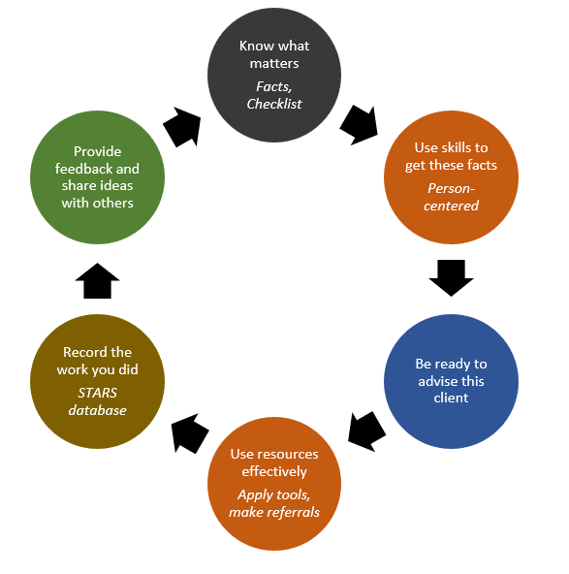

(SHIBA office reference only: What we're about with vol advisors.docx)

PowerPoint slide deck

My SHIBA https://www.insurance.wa.gov/shiba-monthly-person-training

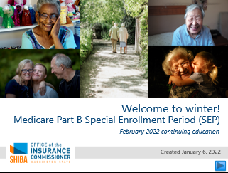

SHIP TA Center job aid for SEP
Medicare Minute Teaching Materials—July 2020
New to Medicare, see #7 on page 7

15-page document found at:
- My SHIBA or
- Login required: https://portal.shiptacenter.org/Portal/Resource/Resource-Detail.aspx?ResourceGUID=9CF560D3-A457-4268-884F-502472DFCB5F

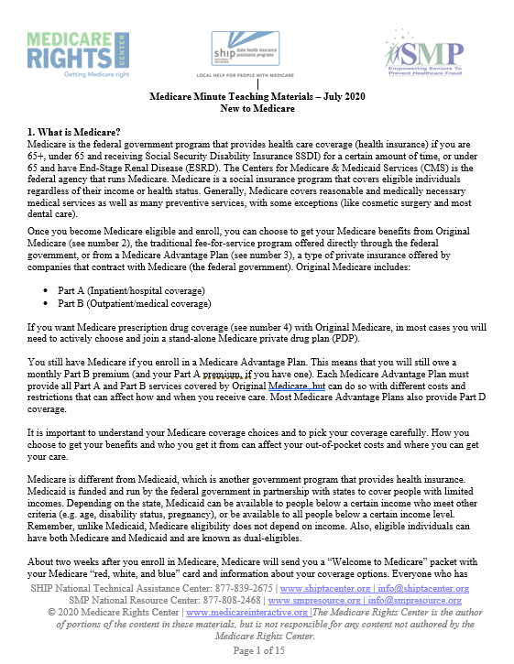

(SHIBA office reference only: Teaching_Materials__July_2020_Medicare_Minute (1).docx)
Medicare Rights Part B Special Enrollment Period (SEP)
Supplementary material for Level 3, Course 4: Medicare Late Enrollment Penalties and IRMAA

4-page document found at:
- My SHIBA or
- Login required: https://miproaws.medicareinteractive.org/SHIP-Courses/Storyline-Courses/3.4-Medicare-Late-Enrollment-Penalties-and-IRMAA/pdf/3-4-part-b-sep.pdf

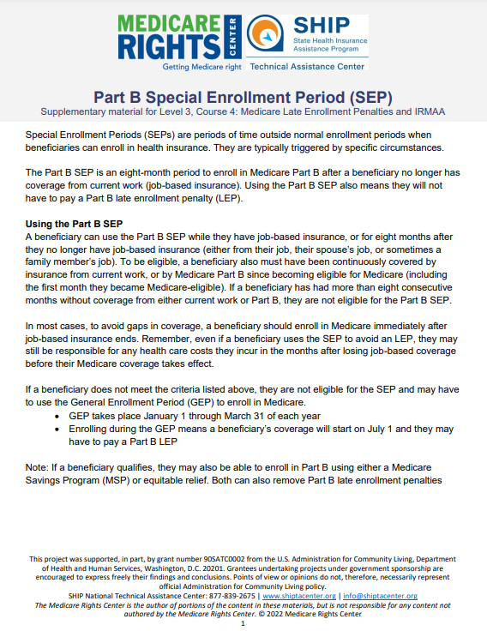

(SHIBA office reference only: 3-4-part-b-sep Level 3 Course 4 Supp Content.pdf)
Nine-block diagram for training objectives

Nine-block diagram for learning objectives
 | Knowledge | Skills/Abilities | Technology
Medicare and related insurance  include social welfare programs | 1 | 2 | 3
Tools and resources  include OIC and other sources | 4 | 5 | 6
Protocols and guidance  include STARS | 7 | 8 | 9

(SHIBA office reference only: learning objectives nine block.xlsx)
Nine-block example
Explained

Nine-block example
Block | Defined | Example
1 | This is knowledge about Medicare - and related insurance programs (e.g. Medicaid). | I know that Medicare-eligible beneficiaries may qualify for a special enrollment period (SEP) when they work past age 65.
2 | This is skills/abilities related to counseling about Medicare - and related insurance programs (e.g. Medicaid). | I can explain to a Medicare-eligible beneficiary the rules about the SEP, for example, when they need to enroll to be on-time.
3 | This is technology related to counseling about Medicare - and related insurance programs (e.g. Medicaid). | I can use my Medicare unique ID to inquire about a beneficiary's status with CMS.
4 | This is knowledge about the tools and resources used in our work. | I know the tools and resources that CMS and the OIC provide guidance about on-time enrollment, for the SEP and where to find those.
5 | This is skills/abilities related to the tools and resources we use in our work. | I can use the tools and resources that CMS and the OIC provide to illustrate to a beneficiary their own right and options and timing for SEP.
6 | This is technology related to the tools and resources we use in our work. | I can order relevant publications from the SHIBA/DES fulfillment for delivery to a client, for example, ahead of our counseling session.
7 | This is knowledge about the protocols and guidance essential to our work. | I know I am expected to gather certain data about the client - both for advising them about their rights and options, and for record-keeping.
8 | This is skills/abilities related to the protocols and guidance essential to our work. | Based on the facts that a client shares with me, I know how to complete the BCF accurately and completely.
9 | This is technology related to the protocols and guidance essential to our work | I am confident and capable to enter into the STARS database the pertinent data from the BCF.

(SHIBA office reference only: Learning objectives nine block.xlsx)

Thanks, and have a great day of training!

